Chapter 3
METHODOLOGY
This chapter presents the research design and the systematic process used to develop SmartHub: a Windows desktop diagnostic tool for Android phones. It details the selection of respondents, the primary and secondary sources of data, the instruments used for data collection, and the techniques employed for data analysis. Furthermore, this section discusses the development framework utilized to build the system, focusing on the Scrum framework. This iterative approach allows continuous refinement of technician workflows such as ADB-based diagnostics, USB-only/no-debug triage for blue/blank/broken-screen devices, and evidence-based reporting, ensuring that the final application meets operational requirements while maintaining high levels of development efficiency and adaptability. The primary stakeholder locale for this project is Carlo Gadget Repair Shop and Accessories.
This chapter outlines the technical framework and procedural steps taken to build SmartHub as online-first diagnostic workstation tool. It provides a comprehensive overview of requirements gathering, architectural design, implementation strategies, and the specific tools used to validate the system's performance. To ensure the final product is both technically sound and operationally relevant, the project uses a hybrid approach combining descriptive and developmental research. The descriptive component is used to document and evaluate existing diagnostic practices (including the limitations of no-USB-debugging cases), while the developmental component governs the actual engineering of the solution, including local evidence collection and optional online analysis. To maintain adaptability throughout the build, the Scrum framework is implemented. This allows the development team to refine features such as connection stability checks, no-debug triage, and report generation through continuous feedback loops and incremental updates.

3.1 Requirement Analysis
The project's methodology outlines the steps, data sources, tools, and data collection techniques that guide the development of SmartHub. In system and software engineering, requirements analysis involves identifying and understanding the needs that a diagnostic application must meet while also balancing the sometimes-conflicting priorities of various stakeholders, including technicians, support personnel, and device owners. This process includes thorough analysis, documentation, validation, and continuous requirements management to ensure the system remains technically sound and user-focused.
For SmartHub, the system requirements are clear, actionable, measurable, and aligned with the project's goal to produce technician-ready results supported by evidence. After collecting relevant information from stakeholders, the developers closely examine current diagnostic challenges, specifically the inefficiencies caused by fragmented evidence capture, intermittent USB behavior, and the difficulty of diagnosing blue/blank/broken-screen devices when USB debugging is unavailable.
At the same time, the developers envision a system that streamlines these manual tasks through a unified offline-first workstation interface, automated evidence collection via ADB/Fastboot when available, USB-only stability sampling when ADB is not available, and clear next-step guidance. Throughout the development process, all requirements are carefully reviewed and validated to ensure the final system directly addresses these gaps and remains within explicit safety boundaries (no security bypass claims, no remote enabling of USB debugging, and no exploit workflows).
At present, many troubleshooting activities rely on a mix of manual checks and ad-hoc tool usage. In no-debug cases, technicians often depend on inconsistent observations and lack standardized evidence. To address these issues, the development team conducts an in-depth assessment of existing workflows by observing diagnostic steps and interviewing intended users. The findings reveal key challenges, including unstructured record-keeping of evidence, limited visibility into device state, and difficulty reproducing intermittent problems.
These findings directly influence the design and functionality of SmartHub v5. The system is envisioned to provide a structured diagnostic summary with evidence (checks and reasons), confidence-aware conclusions, and recommended next actions. By replacing fragmented tools and manual notes with an integrated offline-first platform tailored to diagnostic workflows, SmartHub v5 aims to minimize errors and reduce diagnostic time.

3.1.1 Population and Locale of the Study
The participants of this project consist of primary stakeholders who perform Android phone diagnostics using a Windows workstation. This group is composed of technicians and support personnel who use diagnostic tools daily. The developers use purposive sampling to select these individuals, as their daily interaction with diagnostic workflows provides the necessary firsthand insights into existing procedural difficulties and evidence collection gaps. In this study, these stakeholders are drawn from Carlo Gadget Repair Shop and Accessories.
The study is centered in a Windows-based diagnostic workstation environment at Carlo Gadget Repair Shop and Accessories (e.g., the service counter/repair area) where Android devices are connected via USB for inspection and evidence collection. This locale is ideal for evaluating an offline-first application that integrates local UI, a local companion service, and local device tooling.
To assess usability and user acceptance, the researchers may apply purposive sampling to a small group of intended users who run representative diagnostic scenarios and evaluate the system based on the ISO/IEC 25010 instrument.

3.1.2 Data Instrumentation
The project uses semi-structured interviews, document/tool analysis, direct observation, internet research, and ISO/IEC 25010 as the main tools for collecting data. These instruments help the developers identify current issues, user needs, and system requirements for SmartHub v5.
Semi-Structured Interview Guides. Qualitative data is primarily gathered through semi-structured interviews with technicians and support personnel. This flexible conversational format allows the researchers to ask prepared questions about operational challenges such as device detection, ADB availability, USB instability, and blue/blank-screen triage while leaving room for follow-up inquiries.
Document and Tool Analysis. To ensure the digital system mirrors necessary real-world evidence, the researchers perform an analysis of available diagnostic artifacts and signals (e.g., ADB outputs, Fastboot information, Windows USB enumeration). This analysis informs the design of read-only checks, local history logs, and the formatting of evidence shown to users.
Direct Observation. The researchers conduct on-site or controlled-environment observations of the diagnostic workflow. This provides first-hand insight into common failure modes and evidence capture practices, ensuring the SmartHub v5 interface is optimized for actual use and supports consistent diagnostic conclusions.
ISO/IEC 25010
ISO/IEC 25010 is a standard created by the International Organization for Standardization (ISO) and the International Electrotechnical Commission (IEC) to evaluate software quality. It provides a model for checking and improving software quality through different characteristics and sub-characteristics, including security and compatibility.
The instrument based on ISO/IEC 25010 serves as a tool to measure how acceptable SmartHub v5 is. It evaluates how well the software meets user expectations and needs based on factors such as functionality, performance, usability, and reliability. By including this evaluation, the developers ensure that the system meets technical standards, provides a good user experience, and maintains high reliability-supporting technician workflows for Android diagnostics.
To quantify these results, a Five-Point Likert Scale is utilized as the primary data collection tool. Using a scale ranging from 5 (Strongly Agree) to 1 (Strongly Disagree), the researchers gather perspectives on evidence clarity, speed, usefulness of suggested next steps, and overall usability.
Internet Research
Before developing SmartHub, internet research is used to collect secondary data and study existing tools and practices related to Android diagnostics, ADB/Fastboot utilities, and online-first workstation design. During this process, scholarly articles, documentation, and technical guides are reviewed. The goal is to learn effective practices and common diagnostic features that can be applied to the project while maintaining safe, evidence-based outputs.

3.2 Computer Hardware for Development and Software Requirement Development
This part shows an overview of the basic hardware and software implementation requirements needed to run SmartHub: Diagnostic Application for Android.
Table 3.2 Hardware and Software Requirements
Category | Requirement
Hardware | Windows 10/11 PC; at least 8 GB RAM; stable USB ports; data-capable USB cable; Android device(s) for testing; optional webcam for screen-visual checking
Software (Runtime) | .NET Desktop Runtime (WPF); Microsoft Edge WebView2 Runtime; Node.js; Android platform-tools (ADB/Fastboot); Python 3 for optional offline helpers
Connectivity | Not required for core operation (local-only). Remote access is disabled by default and should only be enabled explicitly in controlled environments

3.3 Software Requirements for System Development
The development of the system involved a range of tools and technologies that were chosen to ensure efficient performance and functionality. The following software and applications were used:
WPF + WebView2 - The Windows desktop host used to package and run the diagnostic UI reliably on Windows.
HTML/CSS/JavaScript - Used to create the user interface and interactive diagnostic flows.
Node.js + Express + TypeScript - Used to build the local companion service and REST endpoints for diagnostics (localhost:3333).
JSON - Used as the data-interchange format between the UI and the local service.
PostgreSQL (Supabase) - Primary cloud storage for user accounts, diagnostic runs, devices, and shared AI context.
Android platform-tools (ADB/Fastboot) - Used to collect device information and evidence when USB debugging is available, and to gather limited signals in other modes.
Python 3- Used for offline-only helpers such as webcam-based screen analysis and offline AI suggestion/scoring for no-debug cases.

3.4 System Framework
In this project, the system framework presents the structured process undertaken to design, develop, and evaluate SmartHub v5. The framework serves as a guide in organizing the activities involved in system development, from requirement analysis up to system implementation and evaluation. It ensures that the development process follows a systematic and organized approach aligned with the objectives of the study.
The development of SmartHub v5 adopts the Scrum approach, a system development methodology that emphasizes iterative development, continuous collaboration, and frequent feedback from stakeholders. This approach allows the developers to divide the system into smaller functional components and develop them in short cycles called sprints. Through this method, system features such as device detection, ADB diagnostics, no-debug connection checks, optional visual checks, and offline evidence history are gradually developed, tested, and improved.
Scrum is suitable for this project because the system involves multiple diagnostic modes and real-world device variability. Each mode requires continuous refinement of system checks and user messaging. The iterative nature of Scrum ensures the system remains flexible and adaptable to changes, while also allowing improvements based on feedback gathered during development.

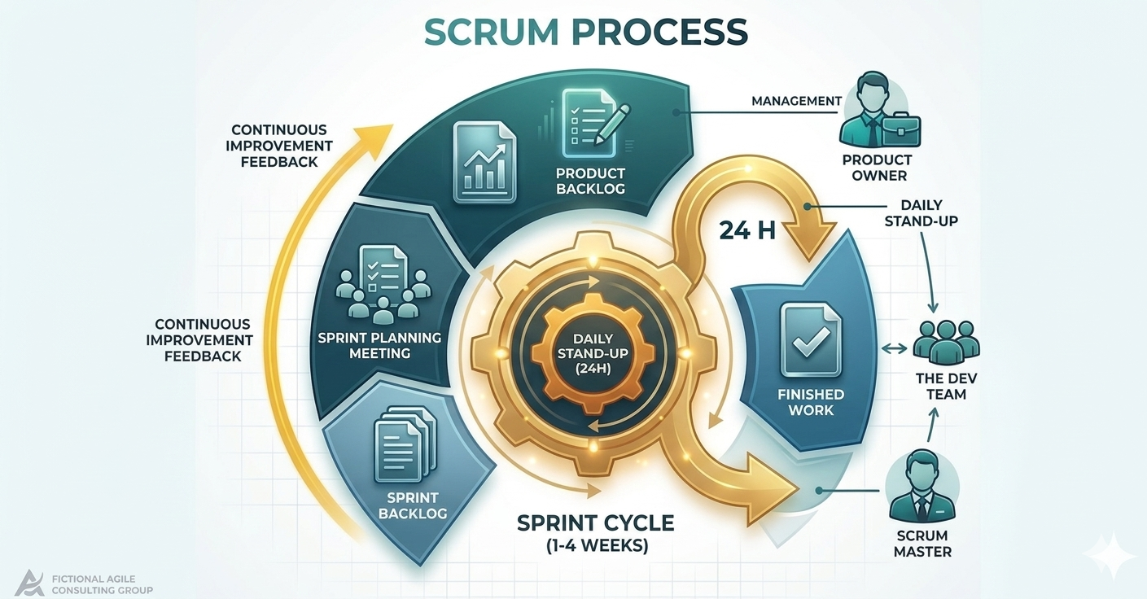
Figure 3.4.1 Scrum Development Framework
Figure 3.4.1 illustrates the Scrum Development Framework used in the development of SmartHub v5. This framework highlights the step-by-step process followed by the researchers in building the system, ensuring that all required diagnostic features are properly implemented and evaluated.
Phases of the Scrum Approach
Product Backlog - The Product Backlog is an ordered list of required features and diagnostic checks (Android Debug Bridge(ADB) evidence collection ,Media Transfer Protocol(MPT) visibility ,USB-only stability sampling, screen-visual checks, SmartHub AI suggestion, and local history) which, according to the Scrum Guide, serves as the single source of work for the team, and moreover, explicitly prioritising online and safety-critical items prevents technical debt in a diagnostic app.

Sprint Planning - Sprint Planning selects backlog items for a sprint and defines tasks and acceptance criteria based on evidence correctness and safety boundaries, which according to Scrum is a time-boxed event to set a Sprint Goal, and moreover, incorporating safety boundaries into acceptance criteria reduces liability when automating device tests.
Sprint Development - Sprint Development designs and implements core modules across UI and backend, integrates local tooling (Android Debug Bridge (ADB), PostgreSQL), and performs continuous testing, which according to Agile engineering practices requires iterative integration, and moreover, continuous testing of Android Debug Bridge (ADB) commands ensures that diagnostic evidence remains reliable across Android versions.
Sprint Review - Sprint Review presents and tests developed features to determine if they meet required specifications while gathering feedback on performance and usability, which according to Scrum validates the increment against stakeholder expectations, and moreover, usability feedback from technicians directly improves first-time fix rates.
Sprint Retrospective - Sprint Retrospective reviews the development process to identify areas for improvement in future sprints, which according to Scrum is a blameless team inspection, and moreover, reflecting on Android Debug Bridge (ADB) integration challenges helps optimise diagnostic speed and reliability.
System Deployment System Deployment System Deployment prepares the application for online workstation use and validates that dependencies and local-only security constraints are met, which according to deployment best practices requires environment-specific validation, and moreover, validating online constraints ensures technicians can diagnose devices with internet access.
To further illustrate the structure and processes of the system, modeling tools are used. These include Data Flow Diagrams (DFD), Use Case Diagrams, and Entity-Relationship Diagrams (ERD),Data Dictionary. These tools provide a clear visualization of how data flows within the system, how users interact with the application, and how different data entities are related.

3.5 Tools for Data Analysis - Data Flow Diagram, Use Case, ERD, Data Dictionary
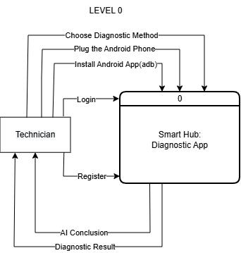
3.5.1 -Data Flow Diagram

LEVEL 0
In this level it shows the complete high-level diagnostic workflow for the SmartHub Windows application, consisting of eight interconnected processes: choosing a diagnostic method, plugging in the Android phone, installing the Android app via ADB, logging in (or registering), generating an online AI conclusion (requiring internet), and producing a diagnostic result. The diagram also identifies two external entities: the Technician (user interacting with the app) and the Smart Hub: Diagnostic App (the system boundary). Data flows between these entities and processes include user commands, USB connection events (managed via MPT (Media Transfer Protocol) for initial device detection), ADB (Android Debug Bridge) commands for low-level device control and APK installation, authentication tokens, sensor data, cloud-based AI inference outputs, and final reports stored in PostgreSQL (via Supabase). MPT is used initially to verify device availability and file-level access, while ADB is used for all diagnostic commands (pulling logs, shell access, hardware interrogation). The AI conclusion is fetched from a cloud model (e.g., OpenAI, custom ML API), and all diagnostic runs are persisted to Supabase PostgreSQL, not to a local SQLite database. According to structured systems analysis and Yourdon/DeMarco Data Flow Diagram (DFD) methodology, a Level 0 diagram (context diagram) represents the entire system as a single process, showing external entities, major data flows, and high-level inputs/outputs, without internal decomposition. According to Android developer documentation, MPT (Media Transfer Protocol) is a USB protocol for basic device identification and media file transfer, used here to confirm the phone is connected. ADB (Android Debug Bridge) is a command-line tool that provides deep device access (shell, logs, package management), required for running diagnostics. According to modern cloud architecture, online AI refers to a machine learning model that is hosted remotely and accessed via API, requiring continuous internet connectivity; it cannot function offline. PostgreSQL is a relational database management system; in SmartHub it is provisioned by Supabase as the primary cloud data store for user accounts, diagnostic runs, and device history.
Moreover, this Level 0 diagram is critical for SmartHub because it establishes system boundaries (technician and Android device as external, while authentication, ADB-based diagnostics, cloud AI inference, and PostgreSQL persistence are internal), identifies mandatory dependencies (USB with MTP+ADB and internet for online AI/Supabase, meaning no offline operation), clarifies protocol roles (MTP for handshake, ADB for privileged tests), corrects previous assumptions (no offline AI or SQLite; all intelligence and persistence are cloud-based), supports risk and security analysis (PostgreSQL RLS and HTTPS AI calls), serves as a traceability artifact linking backlog items to cloud services, and facilitates stakeholder communication (technicians need internet/USB debugging, developers see cloud dependencies, managers confirm offline fallback is unsupported) in summary, the Level 0 diagram reflects an online-first, cloud-native architecture where AI reasoning and data persistence rely on internet connectivity, making it an indispensable planning and communication tool that explicitly names MPT, ADB, online AI, and PostgreSQL to avoid confusion with offline or local-only alternatives.
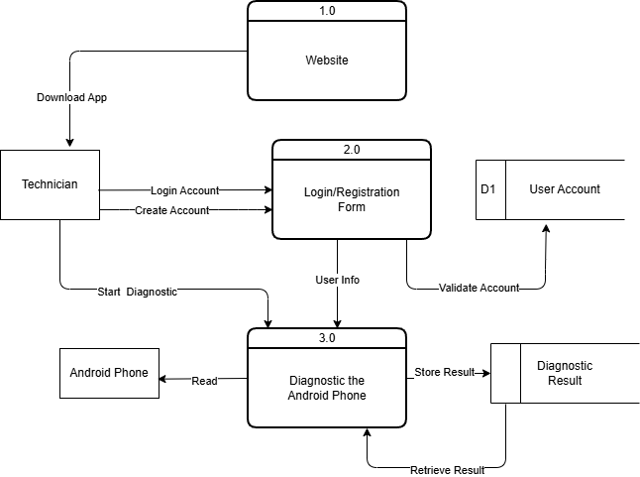
LEVEL 1
In this Level diagram it shows three main processes: 1.0 Website (where the technician downloads the app), 2.0 Login/Registration Form (where user info is collected and account validation occurs), and 3.0 Diagnostic the Android Phone (which includes sub-functions Read, Diagnostic the Android Phone, Store Result, and Retrieve Result). The diagram includes two external entities – Technician and Android Phone – and a persistent data store D2 Diagnostic Result. Data flows include: Download App from Website to Technician, User Info from Technician to Login/Registration, Validate Account (between Login/Registration and an implied user account store, though not explicitly shown as a data store in this diagram), Start Diagnostic from Technician to the Diagnostic process, Store Result from Diagnostic process to D2, Retrieve Result from D2 back to Diagnostic process, and Diagnostic Result from Diagnostic process to Technician. The Android Phone interacts directly with the Diagnostic process. According to structured systems analysis and Yourdon/DeMarco DFD methodology, this diagram represents a Level 1 decomposition of the system, showing the main functional processes, external entities, data flows, and a physical data store (D2 Diagnostic Result). The Website process handles application distribution; the Login/Registration Form process manages user identity and account validation; the Diagnostic process performs the core Android phone testing and result management. The data store D2 Diagnostic Result persists the outcomes of diagnostic runs. Moreover, this Level 1 diagram is critical for SmartHub because it reveals a missing dependency (no explicit flow from the Diagnostic process to the Login/Registration process, implying that Start Diagnostic could be executed without prior authentication – a security risk that should be corrected by linking diagnostic actions through Validate Account), shows a hybrid architecture (Website and Login/Registration are cloud-based while the Diagnostic process is a local Windows app, requiring careful inter-process communication such as API calls), identifies data persistence (diagnostic results are stored in D2 Diagnostic Result, aligning with the decision to use Supabase PostgreSQL rather than local SQLite, though the user account store is not shown and should be added as a separate data store), supports traceability (the Download App flow connects the marketing website to the technician, while Retrieve Result links diagnostic history back to the technician for personalised reporting and trend analysis), and highlights a missing flow (no AI Conclusion process or data flow – an AI inference step should be added between Start Diagnostic and Store Result to match the online AI requirement).

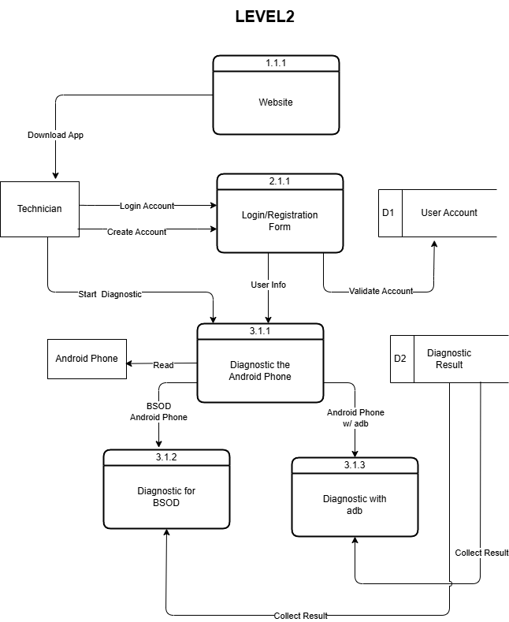

LEVEL 2
In this Level 2 diagram it shows four detailed processes: 1.1.1 Website (delivers the app), 3.1.1 Login/Registration Form (handles account creation and authentication), 3.1.2 Diagnostic for BSOD (specifically diagnoses Blue Screen of Death issues on Android phones), and 3.1.3 Diagnostic with adb (performs deeper diagnostics using ADB commands). External entities include Technician, Android Phone, Android Phone w/ adb (phone with USB debugging enabled), and BSOD Android Phone (phone exhibiting crash symptoms). Two data stores are present: D1 User Account (persists user credentials and profile) and D2 Diagnostic Result (stores diagnostic outcomes). Data flows include: Download App from Website to Technician, Login Account and Create Account between Technician and Login/Registration, Start Diagnostic from Technician to the diagnostic processes, Read from Android Phone to Diagnostic for BSOD, User Info from Technician to Login/Registration, Collect Result from both diagnostic processes to D1 and D2, and interactions with Android Phone w/ adb for ADB-based diagnostics. According to structured systems analysis and Yourdon/DeMarco DFD methodology, this diagram represents a Level 2 decomposition (i.e., a detailed expansion of a Level 1 process, specifically process 3.0 “Diagnostic the Android Phone”). It shows the internal sub-processes (3.1.1, 3.1.2, 3.1.3), their interactions with external entities, and the two data stores. Level 2 DFDs are used to specify the actual logic and data flow at a granular level suitable for implementation planning. Moreover, this Level 2 diagram is critical for SmartHub because it distinguishes two distinct diagnostic paths – BSOD detection (process 3.1.2) which may rely on visual or log-based heuristics, and ADB-based diagnostics (process 3.1.3) which uses privileged commands for hardware and system testing – thereby clarifying the need for both non-invasive and deep-access methods; it also explicitly shows that Collect Result writes to both D1 User Account (for user-level history) and D2 Diagnostic Result (for run-specific data), aligning with the decision to use Supabase PostgreSQL as the unified cloud data store; furthermore, the diagram includes Login Account and Create Account as separate flows, indicating that authentication is required before diagnostic execution, resolving the previous missing-dependency issue; finally, the presence of Android Phone w/ adb as a distinct external entity reminds that USB debugging must be enabled, and BSOD Android Phone acknowledges crash scenarios, ensuring the design covers edge cases.

3.5.2 - Use Case Diagram
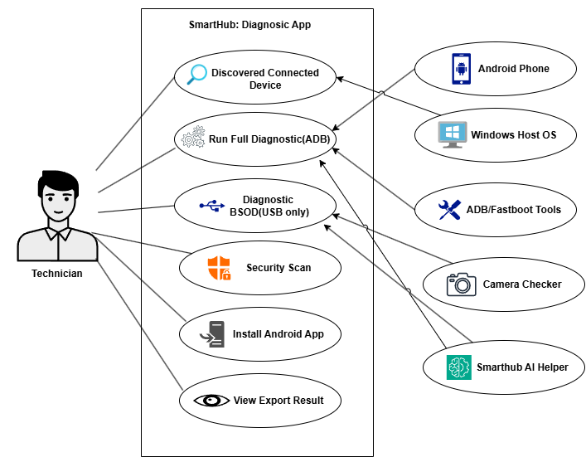
The Use Case Diagram lists the SmartHub Diagnostic App’s core user actions (“Discovered Connected Device”, “Run Full Diagnostic (ADB)”, “Diagnostic BSOD (USB only)”, “Security Scan”, “Install Android App”, “View Export Result”) and supporting tools (“ADB/Fastboot Tools”, “Camera Checker”, “Smarthub AI Helper”); according to software architecture and diagnostic workflow standards (e.g., ISO 25010, Android debugging best practices), these items represent the functional modules that must interact through defined data flows (USB/ADB for device control, MTP for BSOD file access, local or cloud AI for conclusions); moreover, this breakdown is critical for SmartHub because it separates hardware-dependent operations (ADB, MTP, camera checks) from user-facing features (install, view, export) and intelligence (AI helper), ensuring that each component can be developed, tested, and maintained independently while still delivering an integrated diagnostic experience for Android phones.
3.5.3 - Entity-Relationship Diagram (ERD)
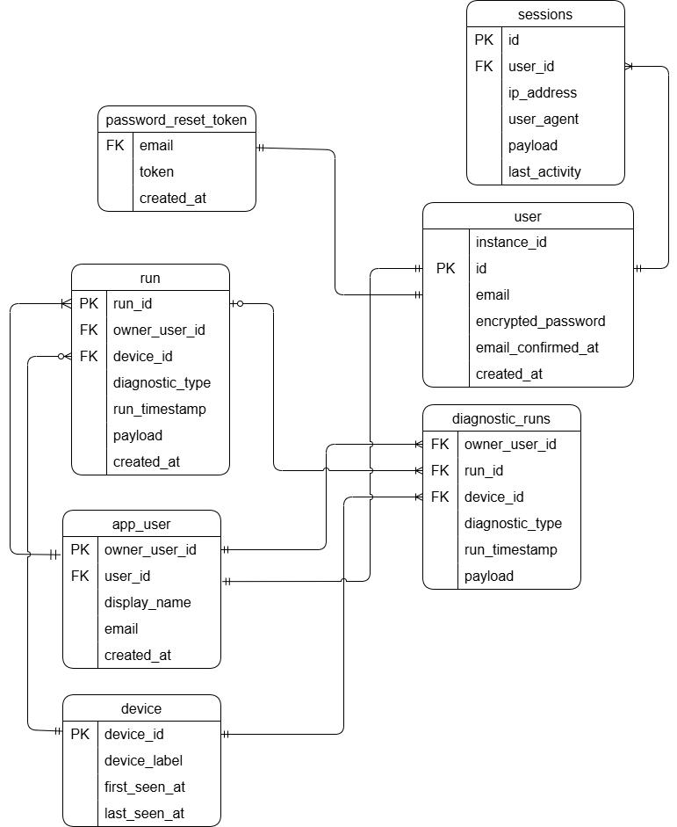
the Crow’s Foot Notation ERD shows six tables (sessions, password_reset_token, run, app_user, device, diagnostics, diagnostic_runs) with primary and foreign keys that define relationships like run.owner_user_id → app_user.owner_user_id (one user, many diagnostic sessions), diagnostic_runs.run_id → run.run_id (one session, many individual test instances), and a direct diagnostic_runs.owner_user_id → app_user.owner_user_id for fast user centric queries, while the diagnostics table appears redundant; according to crow’s foot notation and entity relationship modeling (Martin, 1990), each foreign key implements a one to many relationship where the child table (holding the FK) gets the “many” crow’s foot and the parent table gets the “one” line – for example, app_user (one) → run (many), device (one) → run (many), run (one) → diagnostic_runs (many), plus the direct app_user → diagnostic_runs (many), and even password_reset_token.email (though unusual) still represents one to many; moreover, this ERD directly maps to the SmartHub diagnostic app’s real workflow – authentication and session management (app_user, sessions, password_reset_token) secure each action, starting a diagnostic creates a run record, individual ADB or BSOD tests store results in diagnostic_runs linked to that run, viewing history uses joins across tables (or the direct FK for performance), the schema allows future offline queued writes if needed, and spotting the redundant diagnostics table saves future cleanup – so every foreign key and primary key corresponds to a concrete step in the “authenticate → select device → start session → run multiple tests → store each result → retrieve history” process, making this ERD a faithful blueprint for the app.

3.5.4 - Data Dictionary
This section defines the key tables and fields used by SmartHub to store diagnostic runs, device metadata, user authentication, and session tracking (user, app_user, run, device, diagnostic_runs, password_reset_token, sessions), with descriptions clarifying each field’s purpose according to ISO/IEC 11179 metadata registry standards (ensuring unambiguous data type, format, and relationship documentation), and moreover, this data dictionary provides a single source of truth that enforces referential integrity, supports both online (Supabase PostgreSQL) and potential offline workflows, and eliminates ambiguity for developers, testers, and future schema extensions.
user
Data Name | Field Size | Data Type | Data Format | Description | Example
instance_id | 36 | uuid | UUID | Supabase auth instance identifier | 00000000-0000-0000-0000-000000000000
id | 36 | uuid | UUID | Primary key user identifier | f04d0dc8-7fef-4f8b-9d8b-1f0a12345678
email | 255 | text | email | User email | user@example.com
encrypted_password | 255 | text | hash | Stored password hash | $2a$12$...
email_confirmed_at | 8 bytes | timestamptz | datetime | Email confirmation time | 2026-04-19 09:55:00+00
created_at | 8 bytes | timestamptz | datetime | User creation timestamp | 2026-04-19 09:50:00+00

run
Data Name | Field Size | Data Type | Data Format | Description | Example
run_id | 8 bytes | bigint | integer | Primary key for run | 1713525123
owner_user_id | 36 | uuid | UUID | Foreign key to app_user.owner_user_id | f04d0dc8-7fef-4f8b-9d8b-1f0a12345678
device_id | 64 | text | device id | Foreign key to device.device_id | R58M12345AB
diagnostic_type | 64 | text | text | Type of diagnostic | usb-no-debug
run_timestamp | 8 bytes | bigint | epoch ms | Diagnostic timestamp | 1713525123456
payload | variable | jsonb | JSON object | Diagnostic payload | {"diagStages":{...}}
created_at | 8 bytes | timestamptz | datetime | Row creation time | 2026-04-19 10:12:03+00

app_user
Data Name | Field Size | Data Type | Data Format | Description | Example
owner_user_id | 36 | uuid | UUID | Primary key for app user | f04d0dc8-7fef-4f8b-9d8b-1f0a12345678
user_id | 36 | uuid | UUID | Foreign key to user.id | f04d0dc8-7fef-4f8b-9d8b-1f0a12345678
display_name | 120 | text | text | Display name | Mark Lhemuel
email | 255 | text | email | User email copy | user@example.com
created_at | 8 bytes | timestamptz | datetime | Profile creation timestamp | 2026-04-19 09:51:00+00

device
Data Name | Field Size | Data Type | Data Format | Description | Example
device_id | 64 | text | device id | Primary key device identifier | R58M12345AB
device_label | 120 | text | text | Human-readable device label | Samsung A14 Bench Unit
first_seen_at | 8 bytes | timestamptz | datetime | First seen timestamp | 2026-04-19 09:40:00+00
last_seen_at | 8 bytes | timestamptz | datetime | Most recent seen timestamp | 2026-04-19 10:30:00+00

diagnostic_runs
Data Name | Field Size | Data Type | Data Format | Description | Example
owner_user_id | 36 | uuid | UUID | Foreign key to app_user.owner_user_id | f04d0dc8-7fef-4f8b-9d8b-1f0a12345678
run_id | 8 bytes | bigint | integer | Foreign key to run.run_id | 1713525123
device_id | 64 | text | device id | Foreign key to device.device_id | R58M12345AB
diagnostic_type | 64 | text | text | Type of diagnostic | usb-no-debug
run_timestamp | 8 bytes | bigint | epoch ms | Diagnostic timestamp | 1713525123456
payload | variable | jsonb | JSON object | Diagnostic payload mirror | {"diagStages":{...}}

password_reset_token.
Data Name | Field Size | Data Type | Data Format | Description | Example
email | 255 | text | email | Foreign key email reference to user | user@example.com
token | 255 | text | token | Password reset token value | 4xZs9u...
created_at | 8 bytes | timestamptz | datetime | Token creation timestamp | 2026-04-19 10:10:12+00

sessions
Data Name | Field Size | Data Type | Data Format | Description | Example
id | 255 | text | session id | Primary key of session | s1cf4d8a...
user_id | 36 | uuid | UUID | Foreign key to user.id | f04d0dc8-7fef-4f8b-9d8b-1f0a12345678
ip_address | 45 | text | IPv4/IPv6 | Client IP address | 192.168.1.15
user_agent | variable | text | browser/agent | Client user-agent string | SmartHubDesktop/14.0
payload | variable | text | serialized | Session payload/body | {...}
last_activity | 8 bytes | bigint | epoch | Last activity epoch time | 1713525000

3.6 The Proposed Implementation
Planning Phase – The planning phase identifies stakeholder needs and documents scope, explicitly noting reliance on online AI and Supabase cloud database; according to IEEE 830-1998, requirements must capture network dependencies, security constraints, and API rate limits; moreover, upfront recognition of online-only services forces the team to design retry logic and graceful degradation, avoiding costly redesign later.
Designing Phase – The designing phase creates a high-level architecture (WPF WebView2 shell, local web UI, Node/Express service) with HTTPS clients for Supabase and AI APIs; according to ISO/IEC 42010, the design must account for deployment constraints, security zones, and offline caching of tokens; moreover, decoupling the local UI from cloud services allows swapping AI providers without redeploying the app and enables queuing of diagnostic runs during transient network loss.
Development (Coding) Phase – The development phase implements REST endpoints, UI flows, ADB/Fastboot integration, and optional offline Python helpers, while storing all cloud credentials in environment variables; according to OWASP and ISO 27001, ADB commands must be sanitised, payloads stripped of personal data, and API calls wrapped with timeouts and retry-with-backoff logic; moreover, using online AI and Supabase enables real-time updates, server-side model improvements, and instant result sharing without updating the Windows client.
Testing Phase – The testing phase conducts integration, system, and user acceptance tests using scenarios that include no-debug mode, slow/unstable internet, and AI rate-limit errors; according to ISO 25010, testing must cover functional suitability, reliability, security, and performance, including expired JWT tokens and network failures; moreover, simulating connectivity issues ensures the app shows meaningful error messages instead of crashing, and user acceptance testing verifies that the online dependency does not hinder technicians in real workshops.
Deployment Phase – The deployment phase packages the Windows application with all dependencies (Node, ADB, Python helpers) and ensures local-only security defaults, while requiring outbound HTTPS access to Supabase and AI endpoints; according to Microsoft deployment best practices, the installer must validate connectivity and warn if firewall rules block required domains; moreover, a one-time whitelisting of Supabase and AI domains gives technicians full cloud capabilities (centralised reporting, remote support, model updates) and a local health check guides them to resolve network issues immediately.
Review (Maintenance) Phase – The review phase collects feedback, monitors Supabase and AI logs, and releases updates to the Windows app, local service, or cloud functions; according to ISO/IEC 12207, maintenance includes corrective, adaptive, and perfective changes, including updating AI models without client-side releases; moreover, using online logs and A/B testing on AI endpoints allows the team to improve diagnostic accuracy and schema performance over time without forcing every technician to reinstall the application.

3.7 Statistical Tools
Statistical analysis provides the mathematical framework necessary to interpret the data collected during the system evaluation phase. In this project, these tools are used to analyze feedback from the ISO/IEC 25010 evaluation survey.
The mathematical formula for the weighted average mean is shown below.
Weighted Mean = (Σ(w × x)) / Σw
Where: w = weight assigned to each value; x = each individual response/frequency; Σ = summation.
The developers use the weighted arithmetic mean to determine the average response for each item based on the five (5) options in the questionnaire: 5 (Very Satisfied), 4 (Satisfied), 3 (Neutral), 2 (Unsatisfied), and 1 (Very Unsatisfied).
Table 2.3 Scales and Points of the Questionnaire Survey
Scale | Points
Very Satisfied | 5
Satisfied | 4
Neutral | 3
Unsatisfied | 2
Very Unsatisfied | 1

Table 2.4 Range of the Weighted Mean and its Interpretation
Range of Weighted Mean | Interpretation
4.21 - 5.00 | Respondents are Very Satisfied with the system overall result.
3.41 - 4.20 | Respondents are Satisfied with the system overall result.
2.61 - 3.40 | Respondents are Neutral with the system overall result.
1.81 - 2.60 | Respondents are Unsatisfied with the system overall result.
1.00 - 1.80 | Respondents are Very Unsatisfied with the system overall result.

3.8 Network Diagram
A network diagram serves as a visual representation of how devices and systems interact and exchange data within a digital environment. For this study, the diagram illustrates a local-only architecture, showing how SmartHub connects its users and technical components through localhost communication.

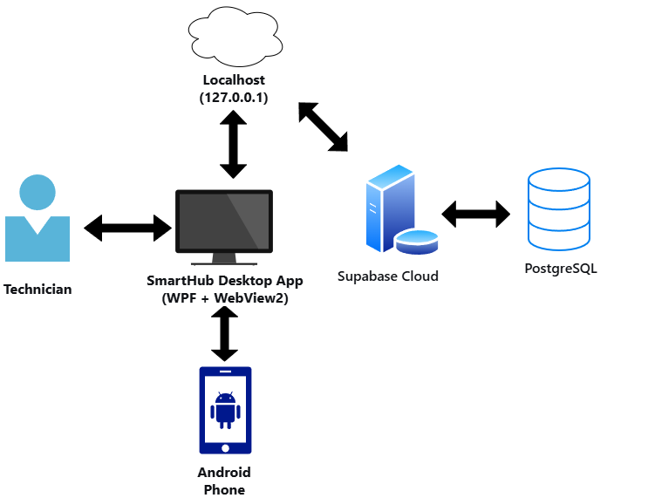
Figure 3.8.1 Network Diagram
Figure 3.8.1 illustrates the SmartHub workstation architecture where the technician uses a Windows desktop shell (WPF + WebView2) to access the diagnostic UI, which communicates via localhost with a local companion service that uses ADB/Fastboot for general diagnostics and MTP specifically for BSOD crash dump retrieval, then sends collected data to online AI APIs for conclusion generation and to Supabase PostgreSQL for cloud storage; according to cloud-native design patterns and zero-trust security principles (NIST SP 800-207), the architecture separates local USB protocol handling (MTP, ADB) from online intelligence and persistence, using HTTPS for all cloud communication and Supabase RLS for data access control moreover, this design ensures that BSOD analysis leverages MTP’s file-level access (avoiding ADB dependencies when the phone is unresponsive), while all diagnostic runs benefit from centralised online AI updates and cross-device history – making the workflow online-first but still capable of local caching for transient network issues, and eliminating the need for manual result backups.

